There are primarily 3 reasons

1. CDN
2. Containers [K8s is a google product]
3. Data management

Why Google Cloud Platform ?

Google has 1 billion user experience in addition to Google Search, Gmail, Youtube, Google Chrome etc Google has invented the MapReduce Programming Model

Google has introduced Bigtable NoSQL database in 2006

The Borg cluster in 2015, with the Omega Scheduler was announced in 2016, which became the opensource project called as Kubernetes Google's contribution to opensource world

Google Cloud Platform: This was introduced in April, 2008, where google announced the preview of Google App Engine, and this service became generally available in November 2011.

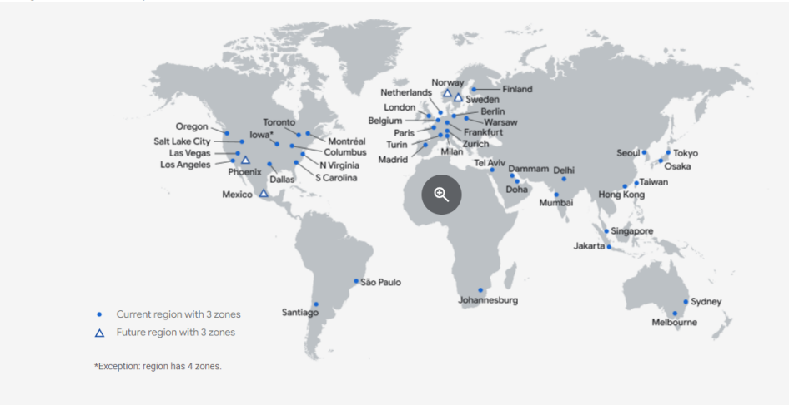

Google Backbone network

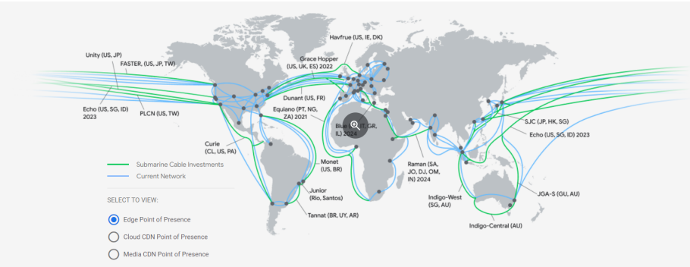

Regions and Zones

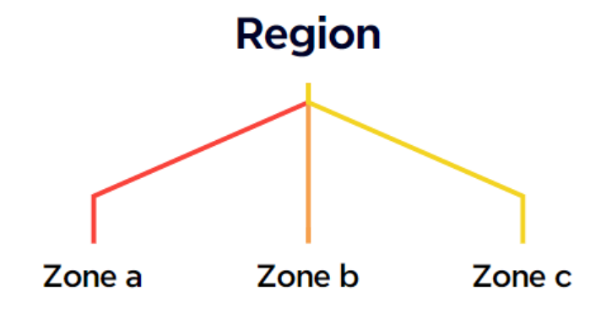

Google Cloud Setup checklist for an enterprise

This setup checklist is a step-by-step guide for anyone who wants to have scalable well architected production and enterprise workloads

Link: <https://cloud.google.com/docs/enterprise/setup-checklist>

How to use terraform in GCP: <https://cloud.google.com/docs/enterprise/deploy-foundation-using-terraform-from-console>

Google Cloud Blueprints

Google has prepared many different methods of implementation for customers A google cloud blueprint is based on Google clouds best practices.

Link: <https://cloud.google.com/docs/terraform/blueprints/terraform-blueprints>

Management interfaces and Command line tools We have the following interfaces to google cloud Google cloud console: Browser based

Cloud Shell: Cloud shell is a Linux Shell provide for every Google cloud user. Here we have set of pre-installed development tools such as gcloud cli, kubectl, Terraform, Git. This shell provides 5GB of persistent disk storage

Cloud APIs: This allows users to interact with Google cloud directly

Config Connector: This is for whom are familiar with kubernetes and would like to manage GCP resources the kuberentes way

Google cloud Deployment manager: This is a deployment service that manages cloud resources via yaml based configuration files

Terraform

